# Chapter 2: Shrubs as magnets for pollination: a test of facilitation and reciprocity in an established shrub-annual system

Ally Ruttan1*, Christopher J. Lortie1

1. Department of Biology, York University, Canada. 4700 Keele St., Toronto, Ontario. M3J 1P3. PH: 416.736.2100 ext. 20588. FAX: 416.736.5698

* Correspondence: 416.736.2100 x 303553, aruttan@rogers.com

October 2017

## Abstract

The magnet hypothesis proposes that flowering plants that are attractive to pollinators can increase the relative pollination rates of neighbouring plants by acting as a ‘magnet’. Here, we test the hypothesis that an animal-pollinated shrub species, *Larrea tridentata,* and a wind-pollinated shrub species, *Ambrosia dumosa*, act as magnets for the pollination of understory annual plant species. As a novel extension to the magnet hypothesis, we further test for reciprocity by the floral island created in the understory of the benefactor shrubs as an additional pollinator magnet for the shrub itself. We monitored pollinators using a combination of video and *in-situ* observation techniques to test the following predictions: 1) shrubs increase pollinator visitation to understory annual plants relative to paired open microsites, 2) annuals under animal-pollinated shrubs benefit through increased pollinator visitation relative to annuals under wind-pollinated shrubs due to the shrub flowers acting as a magnet for the understory, and 3) shrubs with annuals in their understory have higher visitation rates relative to shrubs without annuals due to a concentration of floral resources. Bees were the primary group of pollinators that responded to the treatments in this experiment. We found that both animal and wind-pollinated shrubs increased the visitation rate (but not the duration of visits) by bees to their understory plants. There was no significant difference in pollinator visitation rates between the understories of *Larrea tridentata* and *Ambrosia dumosa*, indicating that shrubs with animal-pollinated flowers do not act as an additional magnet to pollinators. No reciprocal annual-shrub effect was detected, suggesting that the presence of flowering annuals does not influence benefactor shrub species, but also that there is no pollination cost to shrubs. Thus, the concentrated floral resources under desert shrubs likely provide both resources and refuge for bees and act as a search image, but it is likely a commensalistic relationship. These findings support the magnet hypothesis as an additional mechanism of facilitation by shrubs to other plant species within arid ecosystems.

Keywords**:** bees, deserts, indirect interactions,*Larrea tridentata,* magnet hypothesis**,** magnet species effect, MojaveDesert, pollinator facilitation, positive interaction

## Introduction

Positive interactions between plants are a common method of survival for many species. Plant-plant facilitation is especially frequent and well documented in arid environments (Brooker et al. 2008; Filazzola and Lortie 2014, He et al. 2013), where many plants rely on these interactions to survive the high levels of environmental stress (Holmgren et al. 1997; He et al. 2013). While a wide variety of different plant species can facilitate others, the strength of this facilitation varies significantly (Gómez-Aparicio et al. 2004). Shrubs represent a dominant component of many desert landscapes and provide important biotic and abiotic resources for other plants (Castro et al. 2004; Brooker et al. 2008; Filazzola and Lortie 2014). Shrubs are a common benefactor species in desert ecosystems likely because of their relative size, canopy, and capacity to generate an ameliorated microhabitat (Brooker et al. 2008; Armas and Pugnaire 2009). Plants growing in the understory of shrubs are more abundant and have higher growth and survival rates compared to plants growing in the open (He et al. 2013; Filazzola and Lortie 2014). In communities where facilitation by shrubs is common, this leads to a distinct spatial aggregation of annual plants (Pugnaire et a. 1996b; Reynolds et al. 1999; Tirado and Pugnaire 2003; Castellanos et al. 2014). Annuals form concentrated patches under shrubs (Tirado and Pungaire 2003), and fewer plants live out in the open where they are not afforded shelter from extreme heat and desiccation, trampling, and herbivory (Filazzola and Lortie 2014; Perea 2014). Facilitation by resources can also include access to retained water sources and increased soil nutrient levels (Reynolds et al. 1999; Filazzola and Lortie 2014). Flowering shrubs provide significant resources for pollinators both on the shrub, and within their facilitated understories. Given that many annual plants are insect-pollinated, shrubs may be able to facilitate their understories through pollination in addition to the ameliorative effects and abiotic resources they provide (Ruttan et al. 2016). Pollinator interactions have generally not been included in this literature and they represent an important part of desert facilitation networks that needs to be investigated.

Plants and animals constantly interact and plant-plant facilitation may be mediated by animals, including herbivores and pollinators. The scaling of plant-plant facilitation to insects is rarely examined, particularly in deserts (but see: Molina-Montenegro et al. 2006; Molenda et al. 2012; Ruttan et al. 2016). Insects have a strong relationship with plants of all types, and many insects function as pollinators that are essential for plant reproduction and species survival (Allsopp et al 2008). The study of pollinator facilitation was proposed nearly 35 years ago (Rathcke 1983), and predicts that the presence of co-flowering plants increases pollination levels for the surrounding neighbourhood (Feldman et al. 2004). Most of these studies build on an adaptation of the resource concentration hypothesis which suggests that the more resources that are available in an area, the more likely that herbivores are to visit (Root 1973; Kunin 1997). These patterns have also been seen in pollinators. Increased concentrations of floral resources attract higher numbers of pollinators and positively affect pollinator visitation for individual plants within a stand (Ghazoul 2006). The magnet hypothesis (or the magnet species effect) is a more recent development of pollinator facilitation that proposes that a flowering plant that is attractive to pollinators (but not necessarily abundant) can act as a ‘magnet’ and increase the relative rate of pollination for neighbouring plant species (Laverty 1992; Molina-Montenegro et al. 2008). This idea is generally tested using co-flowering plant species, but it has not been tested in documented plant-plant facilitation assemblages. Shrub-annual facilitation complexes in deserts are a good place to test the magnet hypothesis because deserts have a rich diversity of solitary bee species compared to other ecosystems (Minckley 2008) and are highly stressed and thus pre-disposed to many types of facilitation pathways (Brooker et al. 2008). The magnet effect could represent another essential ecological function that shrubs play in deserts.

Facilitation pathways are often multi-directional and non-binary (Rathcke 1983; Pugnaire et al. 1996a; Lortie et al. 2016), but bidirectional interactions that include facilitation are not commonly tested (Bronstein 2009; Schöb et al. 2014). Most of the literature that does report on bidirectional interactions indicates that feedback for the benefactor species is negative (Michalet et al. 2011; Cranston et al. 2012; Schöb et al. 2013). There can be costs associated with facilitation that negatively affect the benefactor species (Michalet et al. 2011). These may include below ground competition for water and nutrient resources that can lead to fitness costs including slowed growth and reduced flower and seed production for the benefactor species (Ludwig et al. 2004; Michalet et al. 2011) Neutral and positive interactions also exist and are important because they increase the potential for co-evolutionary processes to occur within plant-plant interactions (Punaire et al. 1996; Armas and Pugnaire 2005). Examining whether bidirectional interactions are positive, neutral, or negative is important when considering the ecological and evolutionary impacts of these interactions on ecosystem functioning (Schöb et al. 2014). The indirect effect of pollinators is typically not examined in studies of bidirectional facilitation between plants, and represents a novel research gap in this literature. If shrubs can facilitate the pollination of their understory plants, there may also be reciprocal effects on the shrub that should be examined as well. The double-magnet hypothesis that we propose here suggests that the floral island created under shrubs due to plant-plant facilitation pathways not only benefits from increased pollination levels but can also bidirectionally facilitate the shrub through increased pollinator service. Thus, the directionality and reciprocity of facilitation pathways is incredibly important, and can both strengthen or weaken evolutionary relationship between organisms.

This study investigated whether desert shrubs and annual plants facilitate each other through pollination. We hypothesized that the floral resource island created by shrubs and their understory annual plants will have positive non-additive effects on pollinator visitation rates —i.e. would lead to a non-linear increase (Gomez 2005) in pollinator visitations to annual plants under shrubs compared to those in the open. Specifically, we examine the following predictions: (1) the frequency and duration of pollinator visitations to annuals will be greater under shrubs than in the paired, open microsites (magnet hypothesis due to a concentration of understory resources), (2) annuals under flowering animal-pollinated shrubs (*Larrea tridentata*) will have a higher frequency and duration of pollinator visitations than annuals under wind-pollinated shrubs (*Ambrosia dumosa*) because of the higher concentrations of appropriate floral resources on shrubs (specificity of pollinator facilitation), and (3) shrubs with annuals in their understory will have a higher frequency and duration of pollinator visitations than shrubs without annuals in their understory due to increased concentrations of floral resources for pollinators (reciprocal or bidirectional pollinator facilitation, i.e. the double magnet effect). Collectively, these predictions explore how pollinators respond to differential desert plant communities including both insect and wind-pollinated shrubs and their associated annual plants. The relationship between pollinators and plant-plant facilitation networks is important because of their inherent dependence on one another, and for the conservation of ecosystem functioning considering anthropogenic threats to desert ecosystems worldwide.

## Methods

### Study species

This study utilized two shrub species that overlap in range, and are common throughout the Mojave Desert and the Southwestern United States. *Larrea tridentata (*Zygophyllaceae*)* is a large, flowering, entomophilous (insect-pollinated) shrub*,* commonly referred to as creosote bush (Lajtha and Whitford 1989). It is one of the most widely distributed plants found in arid areas of the southwestern United States, including the Mojave Desert (Lajtha and Whitford 1989). *Ambrosia dumosa* (Asteraceae)is a smaller anemophilous (wind-pollinated) shrub, that is also widely distributed in this area (Lajtha and Whitford 1989). Both *L. tridentata* and *A. dumosa* have been shown to facilitate annual plants through physical protection from herbivores and increased water and nutrient access but not through pollination (Whitford et al. 1997; Miriti 2006).

*L. tridentata* is insect pollinated, and over 120 species of bees have been reported visiting its flowers (Hurd and Linsley 1975; Minckley et al. 1999; Minckley et al. 2000). It has densely-packed, medium yellow flowers (<2.5 cm diameter) that frequently bloom for several weeks at a time, between April and May each year (Porter 2014). It is therefore a model species for the study of the magnet effect with shrubs, as the shrub itself provides both significant and attractive floral resources. *A. dumosa* blooms between January and February each year, but is wind-pollinated and is thus a good comparison to *L. tridentata* in this study. Bees and other pollinators typically prefer colourful flowers with easy access to pollen and nectar (McCaul and Primack 1992). Plants with green flowers, such as *A. dumosa*, are visited much less frequently by pollinators and are often pollinated primarily in other ways (McCaul and Primack 1992). While *A. dumosa* does not have big, attractive, showy flowers to act as a magnet for the pollination of understory annuals, the shrub can still provide abiotic mechanisms of facilitation including shade, a windbreak, and protection from predators (Holzapfel and Mahall 1999**)**.

### Study Site

This study was conducted in a 1 mile by 0.25 mile area along Kelbaker Road in the Mojave Desert, just north of Kelso, California, USA (35.061279° -115.664356°; elevation: 779 m; Appendix, Fig. A.1). This area is highly dominated by the shrubs *L. tridentata* and *Ambrosia dumosa,* with shrubs frequently spaced less than two metres apart (Bowers 1984; Lei 1998). Annual plants are common in the area and include the following native species: *Malocothrix glabrata*, *Chaenactis fremontii*, *Eriophyllum wallacei*, *Cryptantha micrantha*, *Camissonia claviformis*, *Phacelia distans*, *Pectocarya spp*., *Eriophyllum lanosum,* and *Rafinesquia neomexicana* (André 2006). Insects and pollinators are also abundant, with a relatively richness of high solitary bee species compared to mesic systems (Minckley 2008). Precipitation is sporadic and low with the 10-year mean accumulated annual precipitation (2004-2014) in for the Mojave Desert at 138 mm (Bowers 1987; Smith et al. 2014). The average daily maximum temperatures in the summer reaches 40°C, and the minimum reaches 1°C in January (1937–2007 records; WRCC 2008).

### Experimental design

To determine whether desert shrubs and their associated understory annual communities act as pollinator magnets, pollinator visitation rates were compared between four treatment groups: 1) *L. tridentata* shrub with understory annuals, 2) *L. tridentata* shrub without understory annuals, 3) *A. dumosa shrub* with understory annuals (in 2016 only), and 4) annuals in an open area at least 1 metre from the drip line of any adjacent shrubs. Background annuals were present in this system but at very low levels. Thus, the annual plant, *Malacothrix glabrata,* was used as a single, controlled phytometer species to test for differential pollinator effects. A phytometer is a species that is representative of the community that can be easily cultivated and controlled, and can be used to test the influence of environmental factors biotically (Clements and Goldsmith 1924; Mwangi et al. 2007). *M. glabrata* was chosen as the phytometer species for this experiment because it is already a wide-spread native annual plant in the area, and it has bright, symmetrical yellow flowers that are comparable to *L. tridentata*. The use of a single, controlled phytometer species allowed for consistency between experimental plots that could not have been attained using *in-situ* annual populations. *M. glabrata* were harvested from nearby areas and transplanted at approximately 20 plants per treatment into 24”x6” planters. Thirty-two sites (each consisting of two *L. tridentata* shrubs, one *A. dumosa* shrub, and an adjacent southern open area) were chosen at random and marked. Open microsites were located 1m to the south of the chosen shrubs and at a minimum of 1 metre away from the drip line of any other shrub. Shrub dimensions were measured for each shrub by first measuring the shrub at the widest point, the perpendicular axis, and the height (Filazzola et al. 2017). Four of these 32 sites (a new site every day) were randomly selected for video recording each morning using a random number generator to avoid repeated measures. Selected sites that did not have flowering *L. tridentata* were not used, the nearest flowering *L. tridentata* was chosen instead. The two *L. tridentata* shrubs within each site were randomly allocated to a treatment (annuals present or annuals not present).

Visitation by pollinators was recorded over an 8-day period during peak flowering, between March 31st and April 12th, 2015, and March 24th and April 17th, 2016. Days were non-consecutive in some cases due to inclement weather. Days with temperatures below 15℃ by 10AM, any sort of precipitation, heavy cloud cover, or excessive wind, were excluded from this study. Four replicates of each treatment group were recorded using Polaroid CUBE Lifestyle HD Action Cameras and three 24”x6” planters of transplanted *M. glabrata* flowers, and two similar-sized branches of flowering *L. tridentata* were recorded for each ‘replicate’, for 1.5 hours daily. Videos were recorded between 10:30AM and 12:00PM, when pollinator activity was at its peak. Fifteen minute *in-situ* observations of plots were performed following video recording by two researchers in a randomly generated order to avoid temporal and observer biases. These data were used to supplement video data and observe pollinator visitation for a greater surface area of the shrubs (approximately 200-flower area). This area was too big to be documented by video whilst retaining enough detail for pollinator identification. Shrub flower density (within a randomly positioned 15cm diameter ring) and *M. glabrata* floral density was also recorded following all daily observations, so as not to disrupt pollinators during data collection. New sites were randomly chosen without replacement each day so that there were no repeated measures.

Twenty HOBO pendent loggers were randomly placed at four areas within the study site, so that there were five replicates per treatment. In each of the four areas, a logger was placed under a *L. tridentata* shrub with annuals present, under a *L. tridentata* shrub with annuals removed, under an *A. dumosa* shrub, and in an adjacent open area to record differences in temperature in each of our treatment groups on an hourly basis. Loggers were placed on the north side of the shrub in all cases.

### Analysis

Videos were processed and visitation data were collected each time an insect visited an open flower for a minimum of one second. The type of pollinator, number of flowers visited, duration of pollination (difference between pollination start and stop times), and any notable behaviours or occurrences (e.g. mating or interactions between pollinators) were recorded. From these data, the total number of visitations and total visitation duration by pollinators were calculated. Due to differences in flower densities between plots, values were standardized by dividing by the number of flowers in the field of view. *In-situ* observations were combined with these data and incorporated into the final values.

An additive term generalized linear model (function: glm) was used to compare both the number (visitation frequency per flower) and duration (visitation time per flower) of pollination of three main insect types (bees, flies, other) (both fit to quasi-Poisson) for each treatment. The treatment group (microsite), insect type, and mean temperature during the hours of recording were treated as fixed factors within each model. Day was modeled as the replicate. Mean video length per treatment per day was used as an offset variable (Thomas et al. 2013), to account for differences in total recording time between videos. An offset variable acts similarly to a covariate in the model, and it takes mean video length into account when modelling interactions. Post hoc comparisons were done using the lsmeans package in R (adjust=tukey) (Lenth 2016). Data for 2015 and 2016 were analyzed separately because the level of factors tested were non-orthogonal due to the addition of the *Ambrosia* treatment in 2016. Linear models were used to compare mean temperature and visitation rates, and number of visits and net floral density (by insect type). All data were analyzed using R version 3.3.2.

## Results

Both shrub species tested, *A. dumosa* (wind-pollinated shrub) and *L. tridentata* (animal-pollinated shrub), had increased visitations to understory plants by pollinators in both years of this study (Fig. 1; Table 1). In 2015, All insect types (bees, flies, and other) had increased visitation rates to *M. glabrata* in the understory of *L. tridentata,* relative to open areas (Fig. 1; Table 1; post hoc, least squared means, bees: p<0.0001, flies: p<0.0001, other: p=0.004). In 2016, bee visitation to *M. glabrata* under *A. dumosa* and *L. tridentata* was also greater relative to *M. glabrata* in the open (Fig. 1; Table 1; post hoc, least squared means, *Larrea:* p=0.016, *Ambrosia:* p=0.043). The visitation duration of pollinators of *M. glabrata* was consistent between treatments, and was unaffected by the presence or absence of *A. dumosa* or *L. tridentata* shrubs for both 2015 and 2016 (Fig. 2). The presence of understory annuals had no reciprocal effects on shrub pollination for either year. Shrubs with *M. glabrata* in their understory did not differ in the frequency or duration of visitation by pollinators of any taxa (bees, flies, or other) compared to shrubs without understory annuals (Fig. 3; Fig. 4; Table 2).

Mean temperature (during video recording hours) positively predicted visitation of bees to annual plants for both 2015 (linear regression, r2adjusted=0.112, df=60, p=0.004) and 2016 (linear regression, r2adjusted=0.038, df=82, p=0.040; Fig. A.2). Floral density positively predicted counts of visitations by bees to annual flowers in 2015 (r2adjusted=0.274, df=60, p<0.0001) and 2016 (r2adjusted=0.880, df=82, p<0.0001; Fig. A.4). Bee visitation to shrub flowers was also positively predicted by shrub flower density for both years (2015: r2adjusted=0.445, df=58, p<0.0001; 2016: r2adjusted=1.0, df=48, p<0.0001; Fig. A.5)

## Discussion

Shrubs are a foundation species within the desert ecosystem and positively influence pollination in their understories. Both the insect-pollinated shrub *L. tridentata* and the wind-pollinated shrub *A. dumosa* facilitated understory plants by increasing visitation rates by bees. These findings support the magnet hypothesis for pollinators in a desert shrub-annual systems. The supplementary floral resources provided by the insect-pollinated shrub *L. tridentata* did not increase pollination for understory plants relative to the wind pollinated shrub *A. dumosa*. This suggests that the identity and direct food resources provided by the shrub matter less to pollinators than the resources that the shrubs provided beneath them. The third prediction associated with the double magnet hypothesis was not supported because shrubs did not receive reciprocal benefits from pollinators when annuals were present. There was also no evidence of competition between shrubs and their understories for pollination, suggesting that there is no pollination cost to shrubs in functioning as floral benefactors to others. These findings support the overarching hypothesis that the floral resource island created by shrubs has positive effects on pollinator visitation rates for understory plants. As such, it is clear the shrubs form important linkages between plant and pollinator taxa and are important components of desert interaction networks.

### Magnet hypothesis

Shrubs are important players in desert communities that mediate pollinator interactions with understory plant species.Shrubs acted as magnets for pollinators and increased the pollination frequency for understory annual plants. Interestingly, these results were not limited to or amplified by the flowering shrub *L. tridentata*. The same patterns of pollinator facilitation were seen in the understory of the wind-pollinated shrub, *A. dumosa.* This suggests that shrubs may act as magnets in a different way than we originally predicted. The floral resources provided by shrubs do not appear to compete with annuals for pollination, but they are also likely not the primary source of the magnet effect demonstrated by shrubs. Thus, shrubs act as magnets and facilitate understory plant pollination through three probable pathways. Firstly, shrubs facilitate an abundance of plants in their understory that provide an area of concentrated floral resources for pollinators. This small area of easily accessible resources allows for increased pollinator productivity in a shorter timeframe (Pyke 1979; Knight 2003). Secondly, shrubs can act as search images for pollinators. The shape and size of shrubs may signal to insects that there are abundant resources nearby, and thus draw them in (Goulson 2000). Thirdly, shrubs can provide abiotic refuge for pollinators to shelter them from intense sun, wind, and even predators (Chaneton et al. 2010). Each of these three pathways of pollinator facilitation represents a novel research gap within the shrub-annual facilitation complex.

Pollinators are responsive to increased floral density, and it can influence visitation rates to flowers. Concentrated floral resources provided within the canopies of facilitative shrubs allow for optimal pollinator foraging. Increased floral resources (to a certain extent) can positively affect pollination for individual and neighbouring plants because pollinators are more likely to forage where they can obtain the most resources with the least amount of effort (Rathcke 1983) —i.e. dense stands with more individual flowers and less distance between them (Pyke 1979; Knight 2003). This supports the increased pollination rates seen for annual plantsunder *L. tridentata* and *A. dumosa* in this experiment. The facilitation by shrubs caused these plants to form concentrated islands of resources within their understories that provided ample resources for pollinators, and thus increased visitation. It is therefore likely that resource concentration and floral density are drivers of the facilitative relationship between shrubs and annuals for pollination in deserts.

The shape and size of shrubs may also play a role in the attraction of pollinators to their understory. Shrubs can act as search images for pollinators—pollinators could use the shape of shrubs as a general indicator of dense understory floral resources that are often scarce in deserts (Rausher 1978; Msnzsr 1985; Goulson 2000). The use of search images in insects is not a novel concept, and it has been shown to increase the rate of discovery of host plants in butterflies and influence foraging in honey bees (Rausher 1978; Msnzsr 1985). Solitary bees were the most frequent pollinators seen in this experiment, with the most common genera visiting both shrubs and annual plants consisting of: *Ashmeadiella, Hoplitis, Megachile, Lasioglossum* (particularly the subgenus *Dialictus*), *Dieunomia*, Andrena, *Agapostemon, Anthidium*, *Dianthidium*, *Habropoda,* and *Perdita.* It is not unreasonable to predict that the solitary bees in this system respond to the presence of shrubs in similar ways that some butterflies and social bees respond to certain images in their environments. The large, regular appearance of shrubs could act as a search image that attracts pollinators and subsequently increases visitation to beneficiary plants in their understories. The sue of shrubs as a search image represents another pathway of indirect interactions between pollinators, shrubs and annual plants that needs further research.

Finally, shrubs likely act as a refuge for pollinators. Shrubs have been found to provide refuge and interact non-trophically with several other animal species, including small mammals and lizards (Lortie et al. 2016, Filazzola et al. 2017). Similar relationships have been found between cushion plants and insects in the alpine where the abundance of both arthropods and pollinators were higher on cushions in contrast to open areas due to the amelioration of abiotic stress (Molina-Montenegro et al. 2006; Molenda et al. 2012; Reid and Lortie 2012). Cushion plants act similarly to desert shrubs by facilitating the species that grow on them through biotic and abiotic mechanisms (Reid and Lortie 2012). The shrub species, *L. tridenta* and *A. dumosa*, could therefore provide a refuge for pollinators through access to resources, shelter, and protection from predators. Thus, the net positive effect of shrubs on the pollination of understory annuals likely involves a complex network of drivers including resource concentration and increased floral density, the ability of shrubs to act as search images for pollinators, and access to abiotic resources and protection from predators. We need to better understand how this facilitative relationship works and the factors that contribute to it to be able to conserve the ecosystem functions that these interactions provide.

### Double magnet hypothesis

Annuals in this system did not influence the pollination of the shrubs that facilitated them. This may be due to an oversaturation in flower density that is above the maximum point in the density-visitation curve, meaning that the addition of shrub flowers and further floral resources no longer had a positive effect on net pollination frequency (Rathcke 1983; Bruninga-Socolar et al. 2016). Though there was no support for the proposed double magnet hypothesis, there was also no pollination cost to shrubs and they may be reciprocally facilitated in other ways. By increasing the frequency of pollination in their understories, shrubs decrease the likelihood that these plants are left un-pollinated. This effectively increases understory plant reproduction, survival and abundance over time. Healthy understory plant populations provide the shrub and its microhabitat with increased water retention and cooling of the soil, seed trapping, increased plant litter, and therefore increased nutrient content (Holmgren et al. 2015; Tirado et al. 2015). The maintenance of a healthy understory can alleviate stress on the shrubs and can positively affect their growth, reproduction, and survival (Sortibrán et al. 2014; Tirado et al. 2015). Shrubs showed no net cost of facilitating understory plant pollination and can even indirectly benefit from this facilitation. This indicates that this is at the very least a commensalistic—but likely mutualistic—relationship.

### Shrubs as foundation species

The ability of shrubs to facilitate pollination for their understory species indicates that they are a foundation species within desert ecosystems. Foundation species are often abundant species that encompass certain structural or functional characteristics that have a strong, defining influence on ecological communities (Ellison et al. 2005). The foundation effect of shrubs on desert plant and pollinator communities should be considered alongside current and emerging ecological threats to these areas. Climate change, the resulting desertification processes, and significant recent declines in pollinator populations are issues that pose an immense threat to deserts (Potts et al. 2010; Scaven and Rafferty 2013). The effects of climate change have caused overall warmer annual temperatures and extreme droughts throughout desert systems, including in California where this study was conducted (Kelly and Goulden 2008; Mann and Gleick 2015). Increasing temperatures pose threats to desert biodiversity and are predicted to decrease species abundance and richness and increase species turnover, with sensitive species being extirpated, and monocultures of more stress-tolerant species taking over (Zeng et al. 2016). Global climate change is also expected increase the occurrence of sustained drought periods, which will deplete ground water stores and may exceed the dormancy allowance for many plant species (Taylor et al. 2013; Carta et al. 2016). This will have negative effects on other levels of biodiversity such as small mammals, reptiles, insects, and pollinators that rely on the rich diversity of plants that are available currently. Climate change has also resulted in significant pollinator declines which present additional challenges in desert ecosystems (Kerr et al. 2015). Climate change can result in a phenological mismatch due to flowers using temperature as a cue for emergence and senescence, and bees primarily using rainfall (Danforth 1986; Forrest 2015). This modifies the temporal overlaps that are required for plant-pollinator interactions (Scaven and Rafferty 2013; Forrest 2015). These increased temperatures would be detrimental to both taxa because they disrupt the network structure of plant-pollinator interactions, even if species aren’t initially lost (Scaven and Rafferty 2013). Declines in pollinators would have a strong, negative impact on seed recruitment and survival in animal-pollinated species, which would have cascading effects to other trophic levels (Lundgren et al. 2015). Shrubs can thus act as a buffer to mediate the effects of warming in desert systems. Their ability to ameliorate abiotic stress in their understories could allow plants to flower for longer periods, avoid early senescence (Talukder et al. 2014), and therefore reduce phenological mismatch and re-introduce temporal overlaps between plants and pollinators. The protection and management of desert shrub species could be an important first step in conserving desert biodiversity and plant-pollinator interactions.

## Conclusions

The desert shrub species *L. tridentata* and *A. dumosa* are important foundation species within the desert community that can facilitate other plants both directly and indirectly. These shrubs facilitate their understories not only by providing physical protection, shade, and access to extra water and nutrient resources, but also by indirectly providing increased access to pollinators. It is proposed that this pollinator facilitation occurs due to concentrated floral resources within their canopies, by providing a search image for pollinators to be able to locate these abundant floral resources, and by providing abiotic refuge for pollinators in similar ways to how they provide them for plants and other animals. This appears to be a commensalistic relationship because shrubs do not receive reciprocal pollinator facilitation from annual plants, although they may be reciprocally facilitating shrubs indirectly in other ways. These findings represent a profound ecological effect that is likely to be an extremely important subset of positive interactions within desert communities. These interactions will be especially important to consider in light of climate change and pollinator declines that threaten these areas, solidifying the position of shrubs as foundation species within deserts.

## References

Allsopp MH, De Lange WJ and Veldtman R. 2008. Valuing insect pollination services with cost of replacement. PLoS One, 3(9), e3128.

André JM. 2006. Vascular flora of the Granite Mountains, San Bernardino County: An annotated checklist. Crossosoma 32(2):38-74.

Armas C and Pugnaire FI. 2009. Ontogenetic shifts in interactions of two dominant shrub species in a semi‐arid coastal sand dune system. Journal of Vegetation Science, 20(3), 535-546.

Armas C, Pugnaire FI. 2005. Plant interactions govern population dynamics in a semi-arid plant community. Journal of Ecology 93: 978–989

Bowers JE. 1984. Plant geography of southwestern sand dunes. Desert Plants.

Bronstein JL. 2009. The evolution of facilitation and mutualism. *Journal of Ecology* **97**: 1160–1170.

Brooker RW, Maestre FT, Callaway RM, Lortie CJ, Cavieres LA, Kunstler G and Armas C. 2008. Facilitation in plant communities: the past, the present, and the future. Journal of Ecology, 96(1), 18-34.

Bruninga-Socolar B, Crone EE and Winfree R. 2016. The Role of Floral Density in Determining Bee Foraging Behavior: A Natural Experiment. Natural Areas Journal, 36(4), 392-399.

Carta A, Probert R, Puglia G, Peruzzi L and Bedini G. 2016. Local climate explains degree of seed dormancy in *Hypericum elodes* L.(Hypericaceae). Plant Biology, 18(S1), 76-82.

Castellanos MC, Donat‐Caerols S, González‐Martínez SC and Verdu M. 2014. Can facilitation influence the spatial genetics of the beneficiary plant population? Journal of Ecology, 102(5), 1214-1221.

Castro J, Zamora R, Hodar JA, Gomez JM and Gómez‐Aparicio L. 2004. Benefits of Using Shrubs as Nurse Plants for Reforestation in Mediterranean Mountains: A 4‐Year Study. Restoration Ecology, 12(3), 352-358.

Chaneton EJ, Noemi Mazía C and Kitzberger T. 2010. Facilitation vs. apparent competition: insect herbivory alters tree seedling recruitment under nurse shrubs in a steppe–woodland ecotone. Journal of Ecology, 98(2), 488-497.

Clements FE and Goldsmith GW. 1924. The Phytometer Method in Ecology: the Plant and Community as Instruments*.*The Carnegie Institution, Washington, DC.

Cranston BH, Callaway RM, Monks A, Dickinson KJM. 2012. Gender and abiotic stress affect community-scale intensity of facilitation and its costs. Journal of Ecology 100: 915–922.

Danforth BN. 1999. Emergence dynamics and bet hedging in a desert bee, *Perdita portalis*. Proceedings of the Royal Society of London B: Biological Sciences, 266(1432), 1985-1994.

Ellison AM, Bank MS, Clinton BD, Colburn EA, Elliott K, Ford CR, Mohan J, et al. 2005. Loss of foundation species: consequences for the structure and dynamics of forested ecosystems. Frontiers in Ecology and the Environment, 3(9), 479-486.

Feldman TS. Morris WF and Wilson WG. 2004. When can two plant species facilitate each other's pollination? Oikos, 105(1), 197-207.

Filazzola A and Lortie CJ. 2014. A systematic review and conceptual framework for the mechanistic pathways of nurse plants. Global ecology and biogeography, 23(12), 1335-1345.

Filazzola A, Westphal M, Powers M, Liczner AR, Woollett DAS, Johnson B and Lortie, CJ. 2017. Non-trophic interactions in deserts: Facilitation, interference, and an endangered lizard species. Basic and Applied Ecology.

Forrest JR. 2015. Plant–pollinator interactions and phenological change: what can we learn about climate impacts from experiments and observations? Oikos, 124(1), 4-13.

Ghazoul J. 2006. Floral diversity and the facilitation of pollination. Journal of Ecology, 94(2), 295-304.

Gomez JM. 2005. Non-additive effects of herbivores and pollinators on *Erysimum* *mediohispanicum* (Cruciferae) fitness. Oecologia, 143(3), 412-418.

Gómez-Aparicio L, Zamora R, Gómez JM, Hódar JA, Castro J and Baraza E. 2004. Applying plant facilitation to forest restoration: a meta-analysis of the use of shrubs as nurseplants. Ecological Applications, 14(4), 1128-1138.

Goulson D. 2000. Are insects flower constant because they use search images to find flowers? Oikos, 88(3), 547-552.

He Q, Bertness MD and Altieri AH. 2013. Global shifts towards positive species interactions with increasing environmental stress. Ecology letters, 16(5), 695-706.

Holmgren M, Lin CY, Murillo JE, Nieuwenhuis A, Penninkhof J, Sanders N, et al. 2015. Positive shrub–tree interactions facilitate woody encroachment in boreal peatlands. *Journal of Ecology*, *103*(1), 58-66.

Holmgren M, Scheffer M and Huston MA. 1997. The interplay of facilitation and competition in plant communities. Ecology, 78(7), 1966-1975.

Holzapfel C and Mahall BE. 1999. Bidirectional facilitation and interference between shrubs and annuals in the Mojave Desert. Ecology, *80*(5), 1747-1761.

Hurd P and Linsley EG. 1975. Some insects other than bees associated with *Larrea tridentata* in the southwestern United States. Proc Entomol Soc Wash 77(1):100-20.

Kelly AE and Goulden ML. 2008. Rapid shifts in plant distribution with recent climate change. Proceedings of the National Academy of Sciences, 105(33), 11823-11826.

Kerr, Jeremy T., Alana Pindar, Paul Galpern, Laurence Packer, Simon G. Potts, Stuart M. Roberts, Pierre Rasmont et al. "Climate change impacts on bumblebees converge across continents." *Science* 349, no. 6244 (2015): 177-180.

Knight TM. 2003. Floral density, pollen limitation, and reproductive success in *Trillium grandiflorum*. Oecologia, 137(4), 557-563.

Kunin WE. 1997. Population size and density effects in pollination: pollinator foraging and plant reproductive success in experimental arrays of *Brassica kaber*. Journal of Ecology 85(2): 225-234.

Lajtha K and Whitford WG. 1989. The effect of water and nitrogen amendments on photosynthesis, leaf demography, and resource-use efficiency in *Larrea tridentata*, a desert evergreen shrub. Oecologia 80(3):341-8.

Laverty TM. 1992. Plant interactions for pollinator visits: a test of the magnet species effect. Oecologia, 89(4): 502-508.

Lenth RV. 2016. Least-squares means: the R package lsmeans. J Stat Softw, 69(1), 1-33.

Lortie CJ, Filazzola A and Sotomayor DA. 2016. Functional assessment of animal interactions with shrub‐facilitation complexes: a formal synthesis and conceptual framework. Functional Ecology, 30(1), 41-51.

Ludwig F, Dawson TE, Prins HHT, Berendse F and Kroon H. 2004. Below‐ground competition between trees and grasses may overwhelm the facilitative effects of hydraulic lift. Ecology letters, 7(8), 623-631.

Lundgren R, Lázaro A and Totland Ø. 2015. Effects of experimentally simulated pollinator decline on recruitment in two European herbs. Journal of Ecology, 103(2), 328-337.

Mann ME and Gleick PH. 2015. Climate change and California drought in the 21st century. Proceedings of the National Academy of Sciences, 112(13), 3858-3859.

Michalet R, Xiao S, Touzard B, Smith DS, Cavieres LA, Callaway RM, Whitham TG. 2011. Phenotypic variation in nurse traits and community feedbacks define an alpine community. Ecology Letters 14: 433–443.

Minckley R. 2008. Faunal composition and species richness differences of bees (Hymenoptera: Apiformes) from two north American regions. Apidologie, 39(1), 176-188.

Minckley RL, Cane JH, Kervin L, Roulston T. 1999. Spatial predictability and resource specialization of bees (hymenoptera: Apoidea) at a superabundant, widespread resource. Biol J Linn Soc 67(1):119-47.

Minckley RL, Cane JH, Kervin L. 2000. Origins and ecological consequences of pollen specialization among desert bees. Proceedings of the Royal Society of London. Series B: Biological Sciences 267(1440):265-71.

Miriti MN. 2006. Ontogenetic shift from facilitation to competition in a desert shrub. Journal of Ecology 94(5): 973-979.

Molenda O, Reid A and Lortie CJ. 2012. The alpine cushion plant *Silene acaulis* as foundation species: a bug’s-eye view to facilitation and microclimate. PLoS One, 7(5), e37223.

Molina-Montenegro MA, Badano EI and Cavieres LA. 2006. Cushion plants as microclimatic shelters for two ladybird beetles species in alpine zone of central Chile. Arctic, Antarctic, and alpine research, 38(2), 224-227.

Molina‐Montenegro MA, Badano EI and Cavieres LA. 2008. Positive interactions among plant species for pollinator service: assessing the ‘magnet species’ concept with invasive species. Oikos, 117(12), 1833-1839.

Mwangi PN, Schmitz M, Scherber C, Roscher C, Schumacher J, Scherer-Lorenzen M, Schmid B, et al. 2007. Niche pre‐emption increases with species richness in experimental plant communities. Journal of Ecology, 95(1), 65-78.

Perea R and Gil L. 2014. Shrubs facilitating seedling performance in ungulate-dominated systems: biotic versus abiotic mechanisms of plant facilitation. European journal of forest research, 133(3), 525-534.

Potts SG, Biesmeijer JC, Kremen C, Neumann P, Schweiger O and Kunin WE. 2010. Global pollinator declines: trends, impacts and drivers. Trends in ecology & evolution, 25(6), 345-353.

Pugnaire FI, Haase P and Puigdefabregas J. 1996a. Facilitation between higher plant species in a semiarid environment. *Ecology*, *77*(5), 1420-1426.

Pugnaire FI, Haase P, Puigdefábregas J, Cueto M, Clark SC and Incoll, LD. 1996b. Facilitation and succession under the canopy of a leguminous shrub, *Retama sphaerocarpa*, in a semi-arid environment in south-east Spain. Oikos, 455-464.

Pyke GH. 1979. The economics of territory size and time budget in the golden-winged sunbird. The American Naturalist, 114(1), 131-145.

Rathcke B.1983. Competition and facilitation among plants for pollination. Pollination Biology, 305-329.

Rausher MD. 1978. Search image for leaf shape in a butterfly. Science, 200(4345), 1071-1073.

Reid AM and Lortie CJ. 2012. Cushion plants are foundation species with positive effects extending to higher trophic levels. Ecosphere, 3(11), 1-18.

Reynolds JF, Virginia RA, Kemp PR, De Soyza AG and Tremmel DC. 1999. Impact of drought on desert shrubs: effects of seasonality and degree of resource island development. Ecological Monographs, 69(1), 69-106.

Root RB. 1973. Organization of a plant-arthropod association in simple and diverse habitats: the fauna of collards (*Brassica oleracea*). Ecological monographs 43(1): 95-124.

Ruttan A, Filazzola A and Lortie CJ. 2016. Shrub-annual facilitation complexes mediate insect community structure in arid environments. Journal of Arid Environments, 134, 1-9.

Schöb C, Michalet R, Cavieres LA, Pugnaire FI, Brooker RW, Butterfield BJ, Cook BJ, Kikvidze Z, Lortie CJ, Xiao S, Al Hayek P, Anthelme F, Cranston BH, García MC, Le Bagousse-Pinguet Y, Reid AM, le Roux PC, Lingua E, Nyakatya MJ, Touzard B, Zhao L and Callaway RM. 2014. A global analysis of bidirectional interactions in alpine plant communities shows facilitators experiencing strong reciprocal fitness costs. - New Phytologist 202: 95-105.

Schöb C, Prieto I, Armas C, Pugnaire FI. 2013. Consequences of facilitation: one plant's benefit is another plant's cost. Functional Ecology. doi: [10.1111/1365-2435.12185](http://dx.doi.org.ezproxy.library.yorku.ca/10.1111/1365-2435.12185).

Smith SD, Charlet TN, Zitzer SF, Abella SR, Vanier CH and Huxman TE. 2014. Long‐term response of a Mojave Desert winter annual plant community to a whole‐ecosystem atmospheric CO2 manipulation (FACE). Global change biology, 20(3), 879-892.

Sortibrán L, Verdú M and Valiente-Banuet A. 2014. Nurses experience reciprocal fitness benefits from their distantly related facilitated plants. Perspectives in Plant Ecology, Evolution and Systematics, 16(5), 228-235.

Talukder ASMHM, McDonald GK and Gill GS. 2014. Effect of short-term heat stress prior to flowering and early grain set on the grain yield of wheat. Field Crops Research, 160, 54-63.

Taylor RG, Scanlon B, Döll P, Rodell M, Van Beek R, Wada Y, Konikow L, et al. 2013. Ground water and climate change. Nature Climate Change, 3(4), 322-329.

Thomas R, Vaughan I and Lello J. 2013. Data analysis with R statistical software. *A guidebook for scientists. Wales, Eco-explore*.

Tirado R, Bråthen KA and Pugnaire FI. 2015. Mutual positive effects between shrubs in an arid ecosystem. *Scientific reports*, *5*, 14710.

Whitford WG, Anderson J, Rice PM. 1997. Stemflow contribution to the ‘fertile island’ effect in Creosote bush, Larrea tridentata. J Arid Environ 35(3):451-7.

WRCC [Western Regional Climate Center], 2008. Western U.S. Historical Climate Summaries. Western Regional Climate Center, Reno, Nevada, USA. Available from: <http://www.wrcc.dri.edu/>.

Zeng Y, Liu T, Zhou XB, Sun QM, Han, ZQ and Liu K. 2016. Effects of climate change on plant composition and diversity in the Gurbantünggüt Desert of northwestern China. Ecological Research, 31(3), 427-439.

Zimmerman M. 1983. Plant reproduction and optimal foraging: experimental nectar manipulations in *Delphinium nelsonii.*Oikos, 57-63.

## Tables

**Table 1.** A summary of the general linear models used to test for differencesin pollinator visitation rates (per flower) to the annual plant *Malacothrix glabrata* between two shrub microsites (*Larrea tridentata* and *Ambrosia dumosa*), and adjacent open microsites. This study was conducted in the Mojave Desert, California (35.061279°, -115.664356°), using video and *in-situ* observation techniques. Pollinator visitation rate (response variable) was standardized by flower density within plots, and total video length was used as an offset variable within models. Boldface denotes significance at p <0.05 for post hoc contrasts using least squared means.

**Table 2.** A summary of the general linear models used to test for differencesin pollinator visitation rates (per flower) to shrub species, *Larrea tridentata,* with the presence of understory annuals (*Malacothrix* glabrata), and without. This study was conducted in the Mojave Desert, California (35.061279°, -115.664356°), using video and *in-situ* observation techniques. Pollinator visitation rate (response variable) was standardized by shrub flower density, and total video length was used as an offset variable within models. Boldface denotes significance at p <0.05 for post hoc contrasts using least squared means.

**Table 1.** A summary of the general linear models used to test for differencesin pollinator visitation rates (per flower) to the annual plant *Malacothrix glabrata* between two shrub microsites (*Larrea tridentata* and *Ambrosia dumosa*), and adjacent open microsites. This study was conducted in the Mojave Desert, California (35.061279°, -115.664356°), using video and *in-situ* observation techniques. Pollinator visitation rate (response variable) was standardized by flower density within plots, and total video length was used as an offset variable within models. Boldface denotes significance at p <0.05 for post hoc contrasts using least squared means.

|  |  |  |  |  |  |  |
| --- | --- | --- | --- | --- | --- | --- |
| **Year** | **Generalized linear model** |  |  |  |  |  |
| 2015 | **Factor** | **Df** | **Deviance** | **P-value** |  |  |
|  | microsite | 1 | 0.236 | 0.254 |  |  |
|  | insect.RTU | 2 | 10.943 | <0.0001 |  |  |
|  | mean.temp | 1 | 15.232 | <0.0001 |  |  |
|  | mictosite:insect.RTU | 2 | 0.310 | 0.003 |  |  |
|  | **Post Hoc, least squared means** | |  |  |  |  |
|  | **Contrasts** | **Estimate** | **SE** | Df | **Z-ratio** | **P-value** |
|  | Larrea,bees - Open,bees | 1.701 | 0.323 | NA | 5.263 | **<.0001** |
|  | Larrea,flies - Open,flies | 2.052 | 0.362 | NA | 5.676 | **<.0001** |
|  | Larrea,other - Open,other | 2.017 | 0.570 | NA | 3.541 | **0.004** |
| **Year** | **Generalized linear model** |  |  |  |  |  |
| 2016 | **Factor** | **Df** | **Deviance** | **P-value** |  |  |
|  | microsite | 2 | 1.373 | 0.214 |  |  |
|  | insect.RTU | 2 | 73.156 | <0.0001 |  |  |
|  | mean.temp | 1 | 7.848 | <0.0001 |  |  |
|  | mictosite:insect.RTU | 4 | 1.007 | 0.687 |  |  |
|  | **Post Hoc, least squared means** | |  |  |  |  |
|  | **Contrasts** | **Estimate** | **SE** | **Df** | **Z-ratio** | **P-value** |
|  | Ambrosia,bees - Larrea bees | -0.059 | 0.150 | NA | -0.391 | 1.0000 |
|  | Ambrosia,bees - Open bees | 0.554 | 0.176 | NA | 3.149 | **0.043** |
|  | Larrea,bees - Open,bees | 0.613 | 0.177 | NA | 3.464 | **0.016** |
|  | Ambrosia,flies - Larrea,flies | -0.023 | 0.453 | NA | -0.051 | 1.000 |
|  | Ambrosia,flies - Open,flies | 0.422 | 0.461 | NA | 0.916 | 0.992 |
|  | Larrea,flies - Open,flies | 0.445 | 0.438 | NA | 1.017 | 0.984 |
|  | Ambrosia,other - Open,other | 0.014 | 0.866 | NA | 0.016 | 1.000 |
|  | Larrea,other - Open,other | -0.959 | 1.133 | NA | -0.847 | 0.995 |

**Table 2.** A summary of the general linear models used to test for differencesin pollinator visitation rates (per flower) to shrub species, *Larrea tridentata,* with the presence of understory annuals (*Malacothrix* glabrata), and without. This study was conducted in the Mojave Desert, California (35.061279°, -115.664356°), using video and *in-situ* observation techniques. Pollinator visitation rate (response variable) was standardized by shrub flower density, and total video length was used as an offset variable within models. Boldface denotes significance at p <0.05 for post hoc contrasts using least squared means.

|  |  |  |  |  |  |  |
| --- | --- | --- | --- | --- | --- | --- |
| **Year** | **Generalized linear model** |  |  |  |  |  |
| 2015 | **Factor** | **Df** | **Deviance** | **P-value** |  |  |
|  | net.treatment | 1 | 2.557 | 0.187 |  |  |
|  | insect.RTU | 2 | 2.334 | 0.009 |  |  |
|  | mean.temp | 1 | 2.334 | 0.931 |  |  |
|  | net.treatment:insect.RTU | 2 | 2.285 | 0.361 |  |  |
|  | **Post Hoc, least squared means** |  |  |  |  |  |
|  | **Contrasts** | **Estimate** | **SE** | **Df** | **Z-ratio** | **P-value** |
|  | Larrea w/annuals,bees - Larrea w/o annuals, bees | 0.075 | 0.206 | NA | -0.364 | 0.999 |
|  | Larrea w/annuals,flies - Larrea w/o annuals, flies | 0.357 | 0.320 | NA | 1.115 | 0.876 |
|  | Larrea w/annuals,other - Larrea w/o annuals, other | 0.780 | 0.533 | NA | -1.465 | 0.687 |
| **Year** | **Generalized linear model** |  |  |  |  |  |
| 2016 | **Factor** | **Df** | **Deviance** | **P-value** |  |  |
|  | net.treatment | 1 | 0.023 | 0.045 |  |  |
|  | insect.RTU | 1 | 0.022 | 0.049 |  |  |
|  | mean.temp | 1 | 0.001 | 0.614 |  |  |
|  | net.treatment:insect.RTU | 1 | 0.028 | 0.024 |  |  |
|  | **Post Hoc, least squared means** |  |  |  |  |  |
|  | **Contrasts** | **Estimate** | **SE** | **Df** | **Z-ratio** | **P-value** |
|  | Larrea w/annuals,bees - Larrea w/o annuals, bees | 0.643 | 0.286 | NA | -2.252 | 0.110 |
|  | Larrea w/annuals,flies - Larrea w/o annuals, flies | 0.447 | 0.497 | NA | 0.899 | 0.805 |
|  | Larrea w/annuals,other - Larrea w/o annuals, other | NA | NA | NA | NA | NA |

## Figures

**Figure 1.** Visitation rate by pollinators to the annual plant *Malacothrix glabrata,* obtained through video and *in-situ* observation. Visitation was compared between the three treatment groups (annuals under *Ambrosia dumosa*, annuals under *Larrea tridentata,* annuals in the open), for bees, flies, and other insect pollinators. Visitation rate was standardized by number of flowers in the field of view of the video. The horizontal lines show the median whereas the boxes represent the interquartile range, whiskers extend to maximum and minimum values unless there are outliers (circles), i.e. data points that are 1.5 times the interquartile range. Shrub treatments that were significantly higher than their open counterpart are denoted with asterisk(s).

Significance at α<0.05: *** = ≤ 0.001, ** = ≤0.01, * = ≤ 0.05.

**Figure 2.** The duration of visits by pollinators to the annual plant *Malacothrix glabrata,* obtained through video and *in-situ* observation. Visitation was compared between the three treatment groups (annuals under *Ambrosia dumosa*, annuals under *Larrea tridentata,* annuals in the open), for bees, flies, and other insect pollinators. Raw visitation times were standardized by total video length. The horizontal lines show the median whereas the boxes represent the interquartile range, whiskers extend to maximum and minimum values unless there are outliers (circles), i.e. data points that are 1.5 times the interquartile range. Shrub treatments that were significantly higher than their open counterpart are denoted with asterisk(s). Significance at α<0.05: *** = ≤ 0.001, ** = ≤0.01, * = ≤ 0.05.

**Figure 3.** Visitation rate by pollinators to *L. tridentata,* obtained through video and *in-situ* observation. Visitation was compared between the two treatment groups (*L. tridentata* with understory annuals present and *L. tridentata* with understory annuals absent), for bees, flies, and other insect pollinators. Visitation rate was standardized by number of flowers in the field of view of the video. The horizontal lines show the median whereas the boxes represent the interquartile range, whiskers extend to maximum and minimum values unless there are outliers (circles), i.e. data points that are 1.5 times the interquartile range. Significance at α<0.05 is denoted as: *** = ≤ 0.001, ** = ≤0.01, * = ≤ 0.05.

**Figure 4.** The duration of visits by pollinators to *L. tridentata,* obtained through video and *in-situ* observation. Visitation was compared between the two treatment groups (*L. tridentata* with understory annuals present and *L. tridentata* with understory annuals absent), for bees, flies, and other insect pollinators. Visitation rate was standardized by total video length. The horizontal lines show the median whereas the boxes represent the interquartile range, whiskers extend to maximum and minimum values unless there are outliers (circles), i.e. data points that are 1.5 times the interquartile range. Significance at α<0.05 is denoted as: *** = ≤ 0.001, ** = ≤0.01, * = ≤ 0.05.

**Figure A.1.** A map of the location of the study site located 3.5 miles North of Kelso, San Bernardino, California, USA, on Kelbaker Road. (central coordinates: 35.061279° -115.664356°; elevation: 779 m). The blue circle represents the approximate area used for data collection. Map generated in R version 3.3.2.

**Figure A.2.** The correlation between mean temperature during hours of video recording, and pollination rate per flower for *Malacothrix glabrata* (frequency of pollination events standardized by the number of flowers in the field of view). Pollination rates were separated by three distinct recognizable taxonomic units of insects (RTUs). Bees showed a significant correlation between temperature and visitation rate to flowers (2015: r2adjusted=0.11, df=60, p=0.004; 2016: r2adjusted=0.04, df=82, p=0.04).

**Figure A.3.** The correlation between mean temperature during hours of video recording, and pollination rate per flower for *L. tridentata* (frequency of pollination events standardized by the number of flowers in the field of view). Pollination rates were separated by three distinct recognizable taxonomic units of insects (RTUs). No significant correlations were present.

**Figure A.4.** The correlation between floral density, and raw pollinator count for *Malacothrix glabrata* during the length of video recording. Pollinator counts were separated by three distinct recognizable taxonomic units of insects (RTUs). Bees showed a significant correlation between floral density and pollinator counts (2015: r2adjusted=0.27, df=60, p<0.0001; 2016: r2adjusted=0.88, df=82, p<0.0001).

**Figure A.5.** The correlation between floral density, and raw pollinator count for *Larrea tridentata* during the length of video recording. Pollinator counts were separated by three distinct recognizable taxonomic units of insects (RTUs). Bees showed a significant correlation between floral density and pollinator counts (2015: r2adjusted=0.45, df=58, p<0.0001; 2016: r2adjusted=1, df=48, p<0.0001).

**Figure 1.** Visitation rate by pollinators to the annual plant *Malacothrix glabrata,* obtained through video and *in-situ* observation. Visitation was compared between the three treatment groups (annuals under *Ambrosia dumosa*, annuals under *Larrea tridentata,* annuals in the open), for bees, flies, and other insect pollinators. Visitation rate was standardized by number of flowers in the field of view of the video. The horizontal lines show the median whereas the boxes represent the interquartile range, whiskers extend to maximum and minimum values unless there are outliers (circles), i.e. data points that are 1.5 times the interquartile range. Shrub treatments that were significantly higher than their open counterpart are denoted with asterisk(s). Significance at α<0.05: *** = ≤ 0.001, ** = ≤0.01, * = ≤ 0.05.

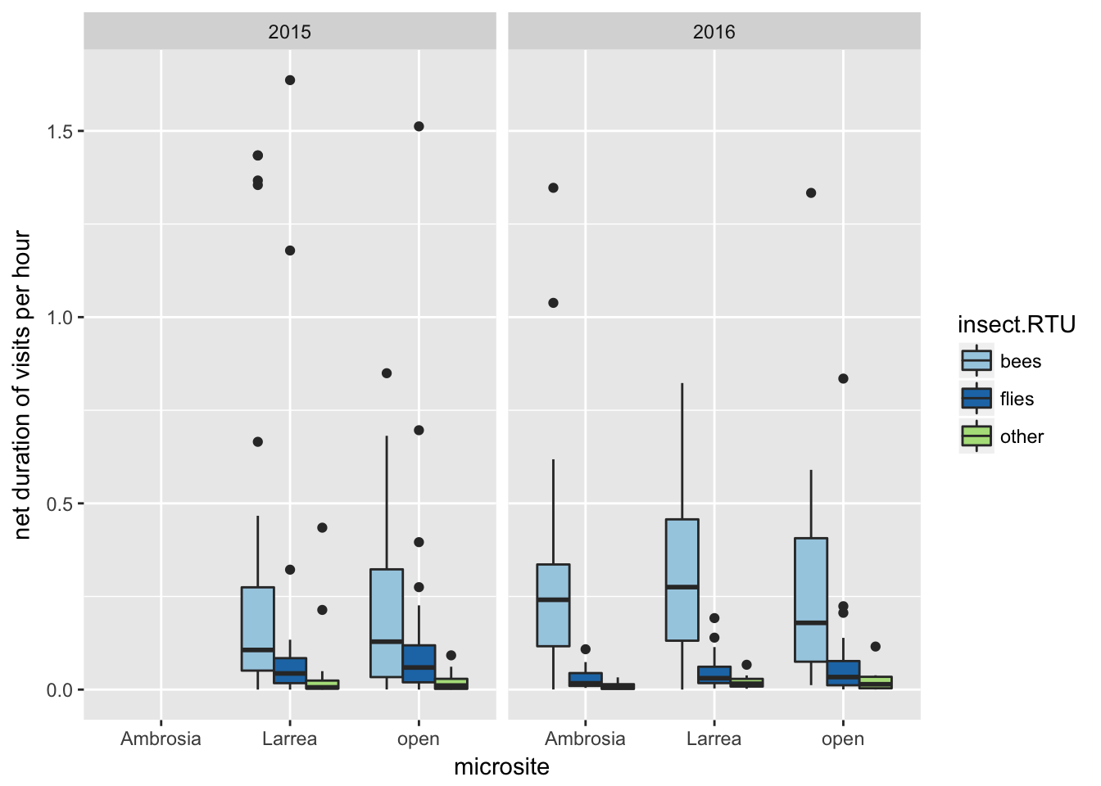

**Figure 2.** The duration of visits by pollinators to the annual plant *Malacothrix glabrata,* obtained through video and *in-situ* observation. Visitation was compared between the three treatment groups (annuals under *Ambrosia dumosa*, annuals under *Larrea tridentata,* annuals in the open), for bees, flies, and other insect pollinators. Raw visitation times were standardized by total video length. The horizontal lines show the median whereas the boxes represent the interquartile range, whiskers extend to maximum and minimum values unless there are outliers (circles), i.e. data points that are 1.5 times the interquartile range. Shrub treatments that were significantly higher than their open counterpart are denoted with asterisk(s). Significance at α<0.05: *** = ≤ 0.001, ** = ≤0.01, * = ≤ 0.05.

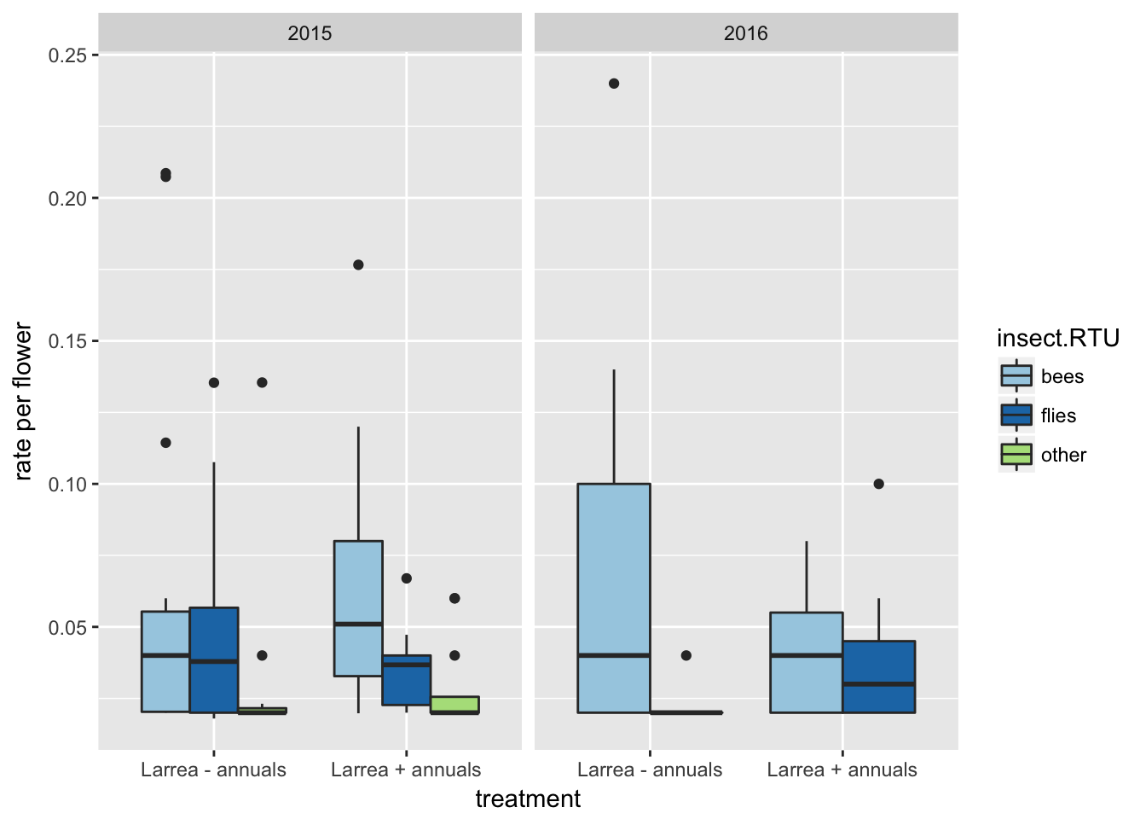

**Figure 3.** Visitation rate by pollinators to *L. tridentata,* obtained through video and *in-situ* observation. Visitation was compared between the two treatment groups (*L. tridentata* with understory annuals present and *L. tridentata* with understory annuals absent), for bees, flies, and other insect pollinators. Visitation rate was standardized by number of flowers in the field of view of the video. The horizontal lines show the median whereas the boxes represent the interquartile range, whiskers extend to maximum and minimum values unless there are outliers (circles), i.e. data points that are 1.5 times the interquartile range. Significance at α<0.05 is denoted as: *** = ≤ 0.001, ** = ≤0.01, * = ≤ 0.05.

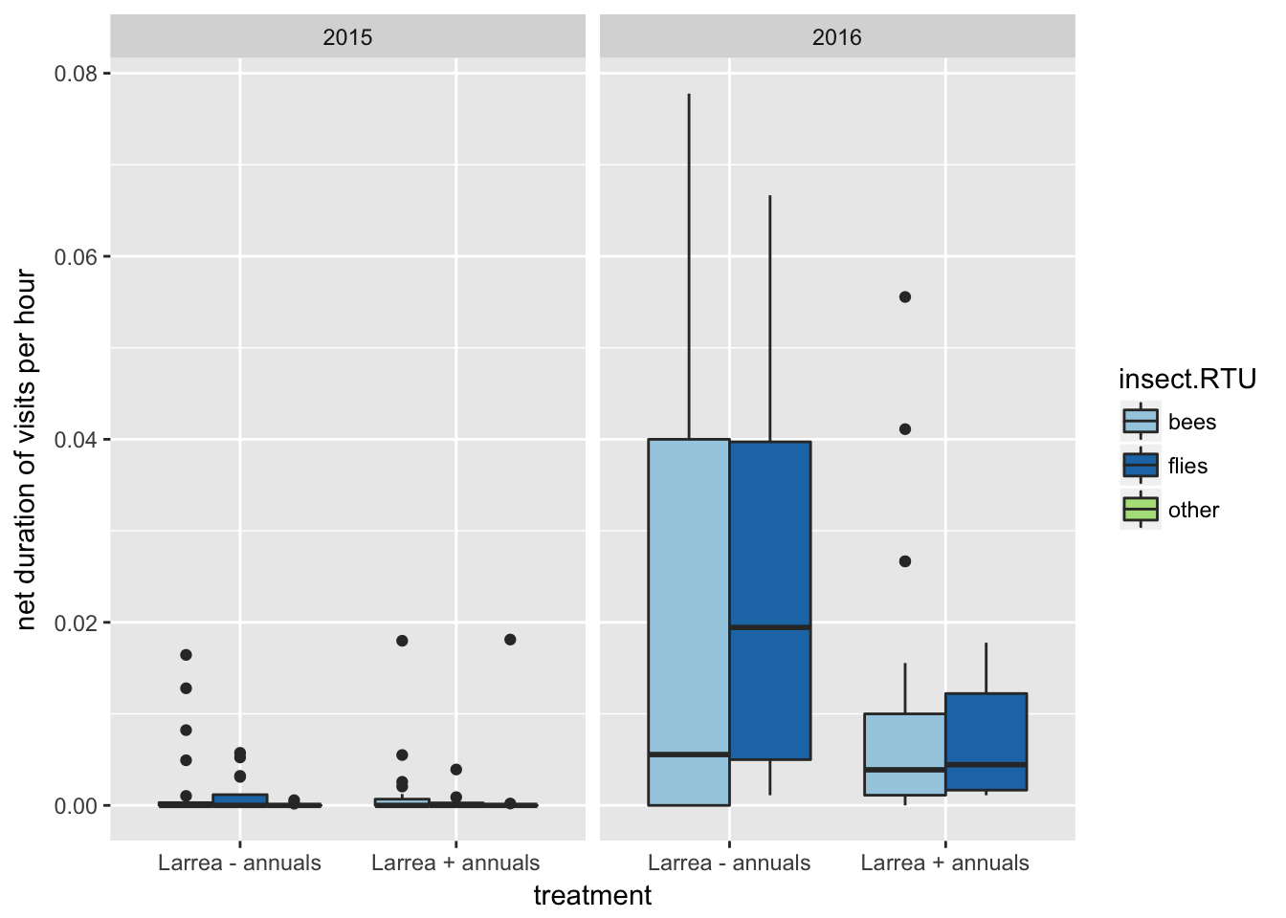

**Figure 4.** The duration of visits by pollinators to *L. tridentata,* obtained through video and *in-situ* observation. Visitation was compared between the two treatment groups (*L. tridentata* with understory annuals present and *L. tridentata* with understory annuals absent), for bees, flies, and other insect pollinators. The horizontal lines show the median whereas the boxes represent the interquartile range, whiskers extend to maximum and minimum values unless there are outliers (circles), i.e. data points that are 1.5 times the interquartile range. Visitation rate was standardized by total video length. Significance at α<0.05 is denoted as: *** = ≤ 0.001, ** = ≤0.01, * = ≤ 0.05.

## Appendix

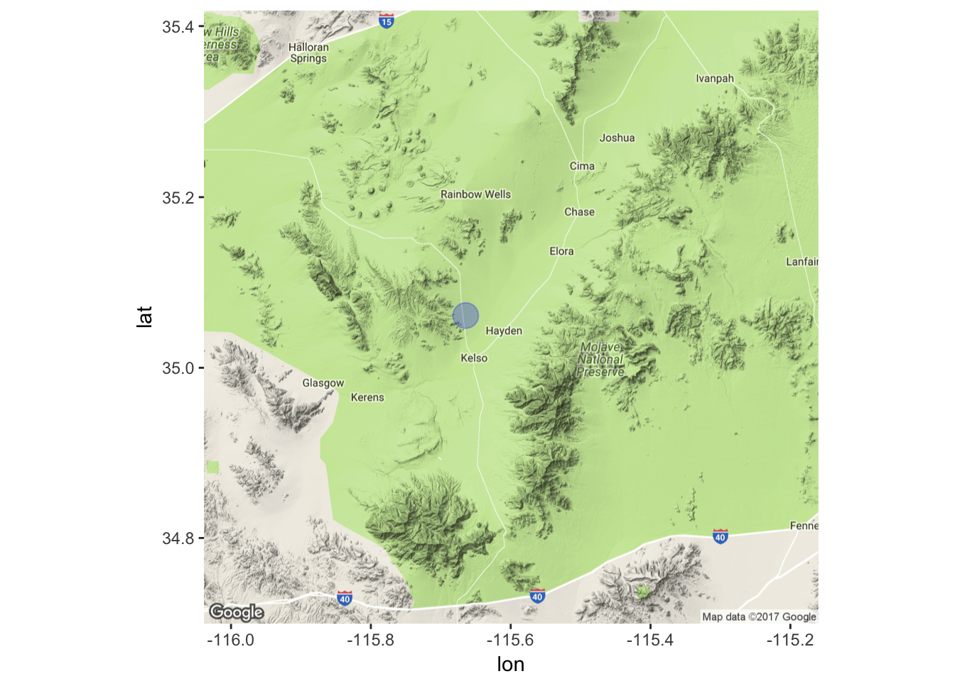

**Figure A.1.** A map of the location of the study site located 3.5 miles North of Kelso, San Bernardino, California, USA, on Kelbaker Road. (central coordinates: 35.061279° -115.664356°; elevation: 779 m). The blue circle represents the approximate area used for data collection. Map generated in R version 3.3.2.

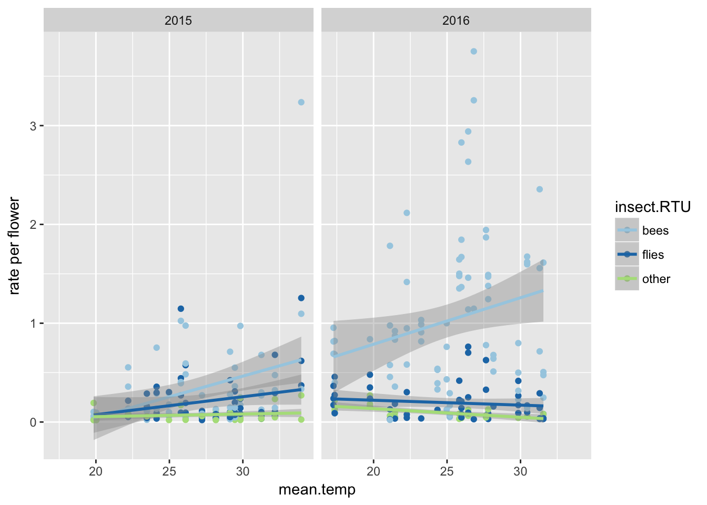

**Figure A.2.** The correlation between mean temperature during hours of video recording, and pollination rate per flower for *Malacothrix glabrata* (frequency of pollination events standardized by the number of flowers in the field of view). Pollination rates were separated by three distinct recognizable taxonomic units of insects (RTUs). Bees showed a significant correlation between temperature and visitation rate to flowers (2015: r2adjusted=0.11, df=60, p=0.004; 2016: r2adjusted=0.04, df=82, p=0.04).

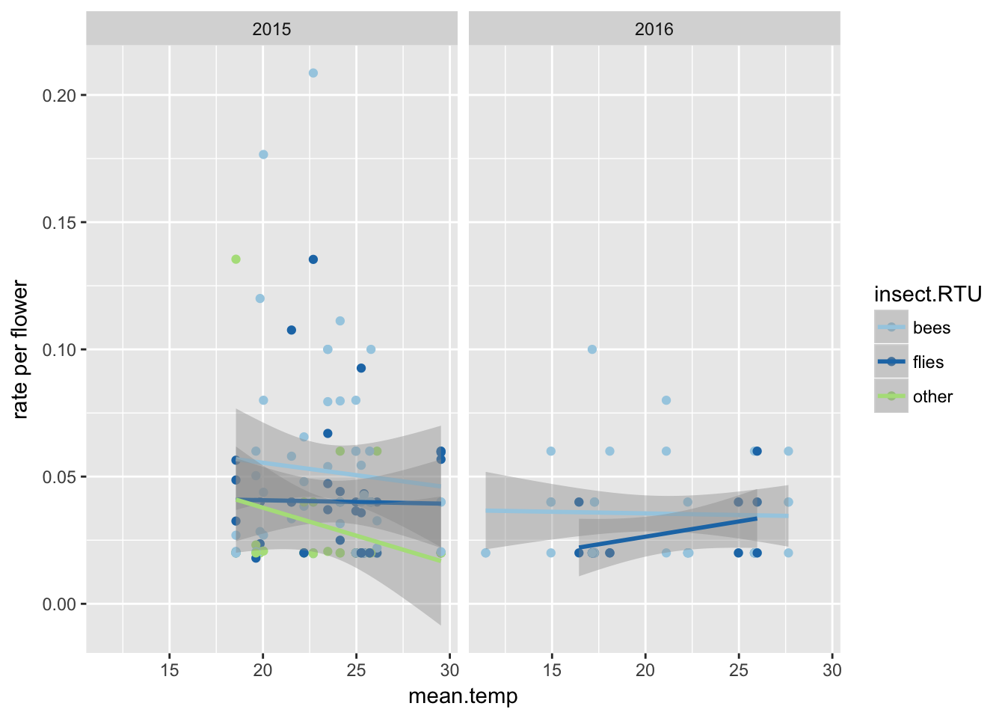

**Figure A.3.** The correlation between mean temperature during hours of video recording, and pollination rate per flower for *L. tridentata* (frequency of pollination events standardized by the number of flowers in the field of view). Pollination rates were separated by three distinct recognizable taxonomic units of insects (RTUs). No significant correlations were present.

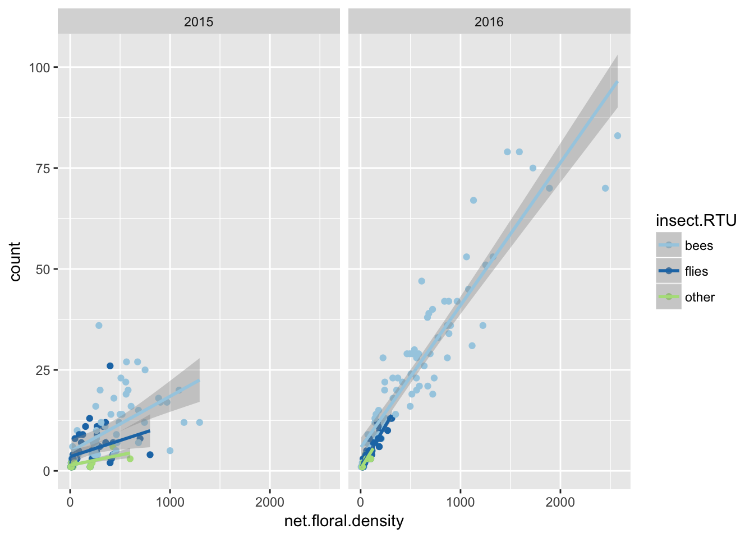

**Figure A.4.** The correlation between floral density, and raw pollinator count for *Malacothrix glabrata* during the length of video recording. Pollinator counts were separated by three distinct recognizable taxonomic units of insects (RTUs). Bees showed a significant correlation between floral density and pollinator counts (2015: r2adjusted=0.27, df=60, p<0.0001; 2016: r2adjusted=0.88, df=82, p<0.0001).

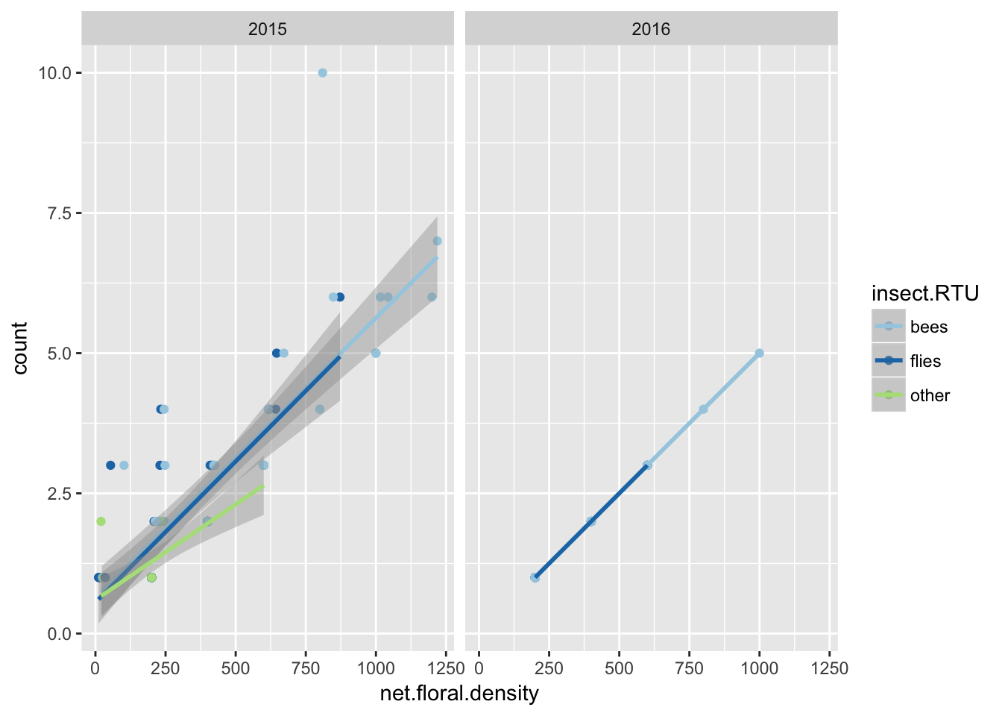

**Figure A.5.** The correlation between floral density, and raw pollinator count for *L. tridentata* during the length of video recording. Pollinator counts were separated by three distinct recognizable taxonomic units of insects (RTUs). Bees showed a significant correlation between floral density and pollinator counts (2015: r2adjusted=0.45, df=58, p<0.0001; 2016: r2adjusted=1, df=48, p<0.0001).